Instructions to authors for the preparation of final paper (max 12 pages)
The title of the paper is typed 16 pt, bold, the initial capitalized only and centered at the top of the page.

Your Name(s)
Your affiliation, address,
postal code, City, Country
Phone: +xx xxx xxxx xxx, Fax: +xx xxx xxxx xxx, your_email@xxx.org
The name of the author(s) is typed 12 pt bold centered in upper and lower case letters. Affiliation(s) and complete address(es) are typed 12 pt centered in upper and lower case letters.

===Explanation of template starts from here. ===
This is a template of full paper for category 2 in the 2nd Mission Idea Contest for Micro/Nano-satellite Utilization.

Please submit your manuscript as a WORD file (.doc) and a PDF file through MIC application page where you submitted the abstract (http://www.spacemic.net/application2.html). Note that only submissions in the English language will be accepted.

The paper should not exceed 12 pages in total length and should strictly adhere to the following outline and formatting guidelines.

Please feel free to contact Contest Secretariat for any questions at info@spacemic.net.

==Explanation ends. Please delete explanation when you write. ==

Abstract: A one paragraph abstract, of not more than 300 words, must be included at the beginning of the paper. It should be a summary (not an introduction) and complete in itself. The abstract should indicate the subject dealt with in the paper and should state the overview of your mission idea. Readers should not have to read the whole paper to understand the abstract.

1. INTRODUCTION

In this section, describe the fundamental need (humanitarian, business, scientific, etc.) your mission idea addresses. For example "Equatorial countries need timely tsunami warnings," and why this need is not being fully addressed by current or conventional large space systems.

1.1 Paper Title

The title of the paper is typed 16 pt, bold, the initial capitalized only and centered at the top of the page. The name of the author(s) is typed 12 pt bold centered in upper and lower case letters. Affiliation(s) and complete address(es) are typed 12 pt centered in upper and lower case letters.

1.2 Headings

Headings of the sections are typed 12 pt in capital letters, placed flush left. Subheadings and sub-subheadings are typed 12 pt in bold upper and lower case letters placed flush left.

1.3 Footnotes

Footnotes should appear only, if absolutely necessary. Footnotes are typed 10 pt.

1.4 Illustrations and Captions

Keep in mind, please, that all figures and graphs will be reproduced exactly as you submit them. Therefore, make sure to provide them in an adequate quality. Place captions, numbered in their respective order, beneath the figures and above the tables, as shown in Table 1 and Fig. 1.

Table 1 Font sizes for papers
Font Size | Appearance (in Time New Roman or similar looking fonts)
Font Size | Regular | Bold | Italic
16 |  | title
12 | author email, address and affiliation | Author name(s)  Headings (in capital letters),  Subheadings and  Sub-subheadings (in upper and lower case letters)
11 | cell in a table | table caption,  figure caption
10 | reference item  abstract body | abstract heading | reference item (partial)

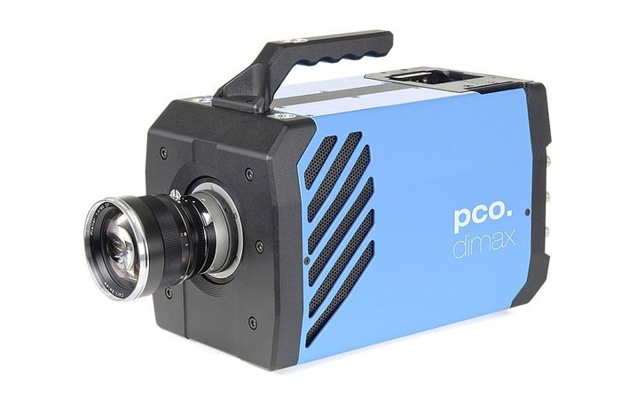
Fig. 1 Example of an unacceptable low-resolution image

1.5 Symbols and Abbreviations

Use only standard symbols in text and illustrations. Unusual units and abbreviations should be defined the first time they are used.

1.6 Equations

The numbers identifying equations should be placed in parentheses on the right. Please, make sure that no ambiguities arise.

1.7 Sections

The manuscript should be divided into sections, subsections and sub-subsections with clearly marked subtitles (in accordnace to instructions in section 1.2 above) and numbered numerically (e.g. 2.1.3). Type the main body of the text single-spaced, beginning flush left. Leave one blank line between paragraphs and between paragraphs and headings/sub-headings.

1.8 Fonts

If possible, the font Times New Roman, 12 pt, or similar looking fonts should be used.

1.9 Page Numbers

Do not apply page numbering.

2. KEY CONCEPT AND BUSINESS IMPACET ON SOCIETY AND ENVIRONMENT

Describe your value proposition. State clearly how your business idea improves life styles, industries and natural environment of regions, countries and/or the Earth.

3. BUSINESS MODEL STRUCTURE

Describe the fundamental business components characterized by 5W2H, namely, Who, When, Where, What, How, Why and How much. You must clearly identify who the service provider is, when and/or how often the service becomes available, in what regions and countries. The nature of the product or service is most important as well as how they are delivered to the recipients. At last, but not the least why such products or service are important for the proposed costs (price) must be included.

4. BUSINESS FEASIBILITY

Examine Business Feasibility by estimation of the revenue versus costs based on your mission model. Include your cost table in your proposal to confirm that the revenue balances against the cost and the investment. For estimating cost, refer to the Cost Model, Cost Model Guidance Book, and Cost Estimation Tips.

5. LOGISTICAL FEASIBILITY

Clarify the key system elements in your mission model. Those elements must include (1) payload and bus level of the satellite, (2) the number of satellites, (3) the number and specifications of ground stations and (4) launch configuration with reasons.

6. RISK ANALYSIS

Specify any risks involved in the proposed business model.

7. REFERENCES

References to published literature should be quoted in the text in brackets and grouped at the end of the paper in numerical order, typed 10 pt and presented as follows:

[1] J. K. Knowles and E. Reissner, Note on stress-strain relations for thin, elastic shells. J. Math. Phys. 37, 269-282 (1958)
[2] H. S. Carslaw and J. C. Jaeger, Operational Methods in Applied Mathematics, 2nd edition. p.121. Oxford University Press, London (1953)
[3] Authors’ Guidelines. Available online at: www.dlr.de/iaa.symp (accessed August 2010)

